**Module 19**

**Cloud computing**

Cloud computing is service which work over the internet and provide services like storage, powerful processor, local server.

Example of cloud is gmail, facebook, Dropbox.

**Advantage of cloud computing**

* Cost saving
* High speed
* Back up and restore data
* Unlimited storage

**Disdvantage of cloud computing**

* Security threat in cloud storage.
* Only work in internet connectivity.
* Lower Bandwidth.
* Lack of support.

**Computing Five Essential characteristic to cloud**

**On Demand Self Service**

Cloud computing service do not require much human interaction means, in cloud computing user can himself and customize the monitor or resource like he can create own service, own mailbox, etc.

**Broad Network Access**

Broad network access means cloud can be accessed by enterprises from anywhere. Or user can access the cloud service form any where and from any device like laptop, smart phone, Pc.

Example:- nowadays people can easily take ticket via internet.

**Resource Pooling**

When a particular cloud service can be used by multiple user and it is accessible to every user with same efficient, but every user has its own privacy.

Example :- suppose that, in one building many people live as a rental, so every one use same building infrastructure, but every one has its own privacy.

**Rapid Elasticity**

When cloud service get large traffic beyond to the expectation than cloud increase its capability to receive all traffic.

Example :- It is like that, suppose that there is bus service and at a time of occasion crowd rises too much, so bus authority increase the no of bus at same time and soon as crowd get low bus authority decrease the no of bus.

**Measured service**

User only have to pay for that storage, what they required. This give transparency to both the service provider and the consumer.

**Infrastructure as a service(IaaS):**

IaaS cloud computing means it offer essential service like computing power, storage and networking resources on demand and on pay. Here we get the Infrastructure of cloud.

**Password as a service (PaaS)**

PaaS cloud computing used for development and deployment of application. This platform offer to host the virtual environment configuration,

**Software as a Service (Saas)**

This platform used for software development over the internet. The provider charges for the services by advertising or by sharing multiple users application like google docs, calender.

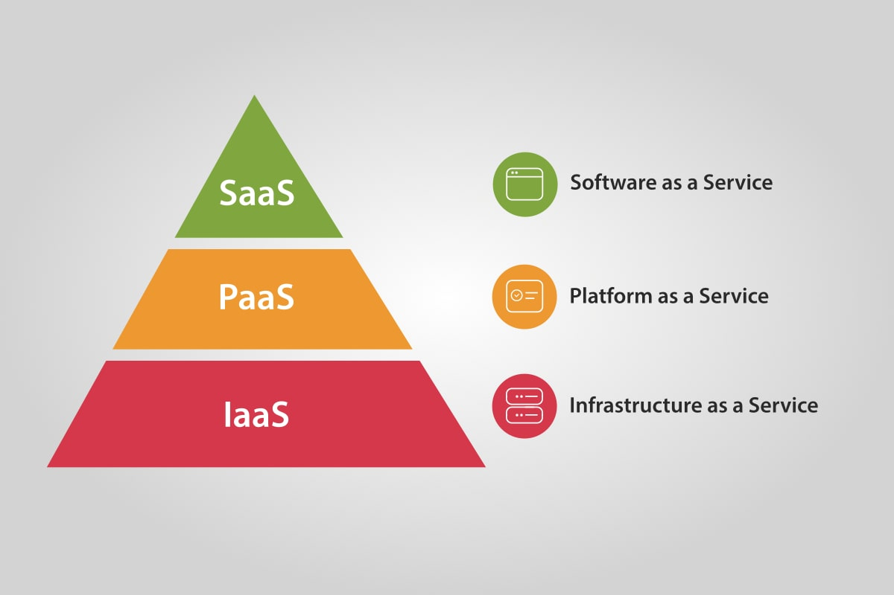

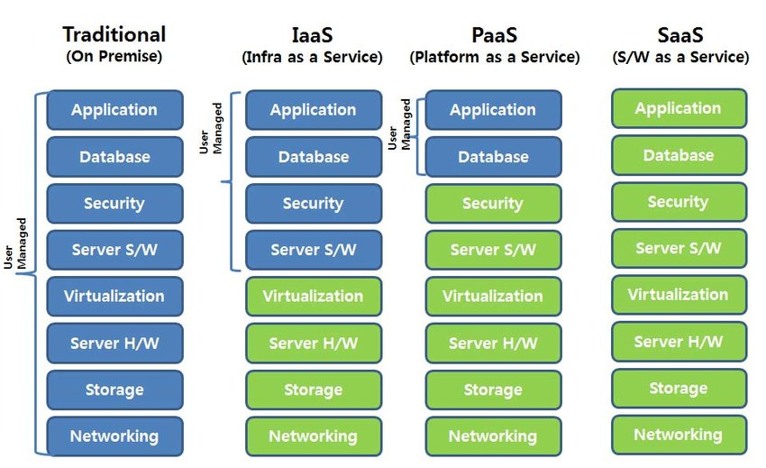

**Cloud Deployment Model**

**Private cloud:**

When cloud service is used for single organization with its own firewall and policy it is know as private cloud.

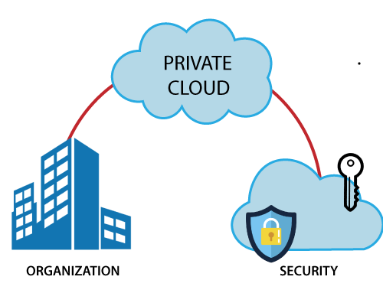

**Public cloud:**

When cloud provider makes services such as application, server, storage available to the public. So the people can create his own account and used cloud service.

Example :- Google drive, Dropbox, vmware.

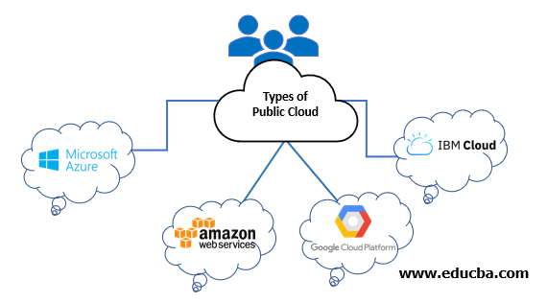

**Community cloud:**

In community cloud service it allows the several group of organization to access same cloud service. It is owned or managed by several organization in the community.

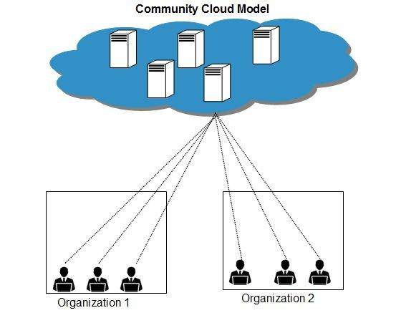

**Hybrid cloud**

In hybrid cloud it is combination of two or more cloud like it is consist of private, public, community cloud.

All cloud are interconnected with its but they keep security infrastructure. So public user can’t access the private cloud.

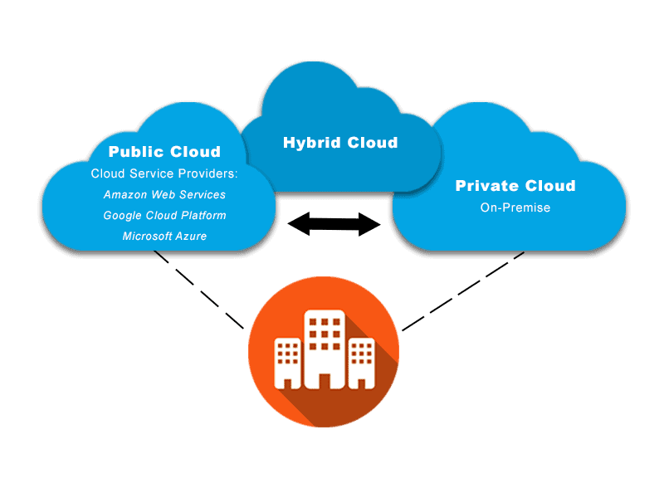

Types of cloud

* AWS
* AZURE
* GCP
* IBM

**What is container?**

Container are packages where all the dependency are present in that package so that operating system is virtualized by container so it can be run from anywhere.

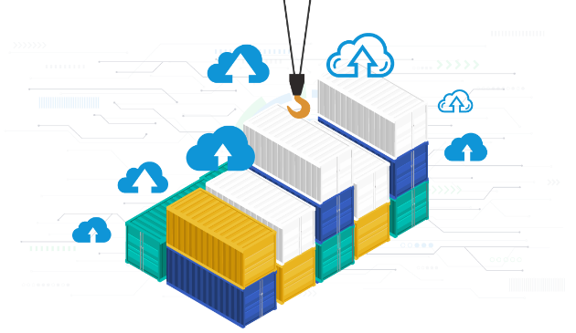 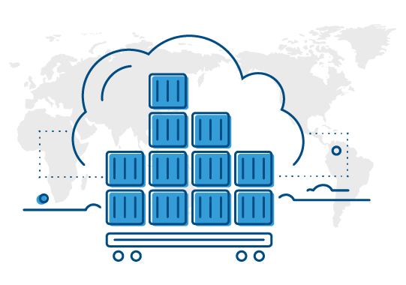

**Virtual machine**

It is an essential technology allow user to run multiple os on single physical system and share the under lying the resource. It work on hyper-vision technology.

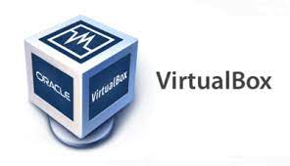 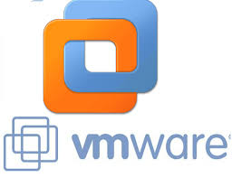

**Difference between Virtual and Container**

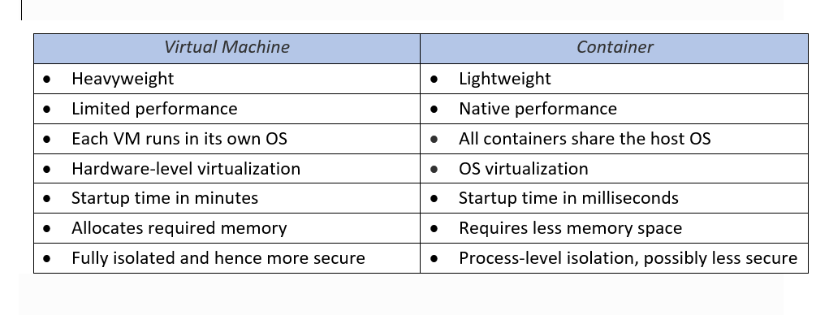

**What is Docker**

Docker is a tool which create virtual machine and run on the concept of container. Actually it is a engine which is used to deploy the application quickly.

Suppose that if you need to install or develop an application for that we need to download dependency of that application and if we need it to send on another machine we need to follow the same process in which we need to install all dependencies but in docker we can create an image file of application which can be execute any OS, any Machine. Because it consist of all dependency and requirement tools.

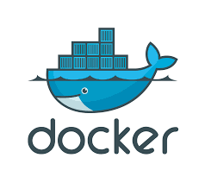

**What is Kubernetes**

Kubernetes is a controller of docker, it manage and control the docker. It is also known as K8s.

It is developed by google. It provide an efficient way for packaging and running application. If container experience failure another container boot automatically this resilience is provided by kubernates.

